**CSC 138 Web server**

DELIVERABLE REPORT (code enclosed in zip file along with html’s)

Objective: create a server that accepts incoming connection to client and displays a hello world html file to the browser that is located in its repository. If the requested file cannot be found on server database then display HTTP/1.1 404 Not Found. In this particular server the html error message is a default html file sent if there is a problem finding the requested file name. This is done because the browser will interpret the error message into its own version of what it thinks happened. Just so that we could display exactly what the teacher asked

Design: used python socket library functions to create a server that listens on only one socket (meaning no more connections will be excepted. Once the connection is established the server parses the incoming message and attempts to open a file if the file open fails then we throw an exception and catch it returning the error html file to the requesting user.

Documented code and actual output of a typical communication between client and web server and proof that it works.

Documented code:

#import socket module

from socket import *

serverPort=80

serverSocket = socket(AF_INET, SOCK_STREAM)

#Prepare a sever socket

serverSocket.bind(('',serverPort))

serverSocket.listen(1)

print 'the web server is up on port:',serverPort

while True:

#Establish the connection

print 'Ready to serve...'

connectionSocket, addr = serverSocket.accept()

try:

message = connectionSocket.recv(1024)

print message,'::',message.split()[0],':',message.split()[1]

filename = message.split()[1]

print filename,'||',filename[1:]

f = open(filename[1:])

outputdata = f.read()

print outputdata

#Send one HTTP header line into socket

#Fill in start

connectionSocket.send('\nHTTP/1.1 200 OK\n\n')

connectionSocket.send(outputdata)

#Fill in end

#Send the content of the requested file to the client

for i in range(0, len(outputdata)):

connectionSocket.send(outputdata[i])

connectionSocket.close()

except IOError:

#Send response message for file not found

errorfile="error.html"

f=open(errorfile)

print "no file found"

errorout=f.read()

connectionSocket.send('\nHTTP/1.1 200 OK\n\n')

connectionSocket.send(errorout)

serverSocket.close();

proof that it works:

File requested is good!

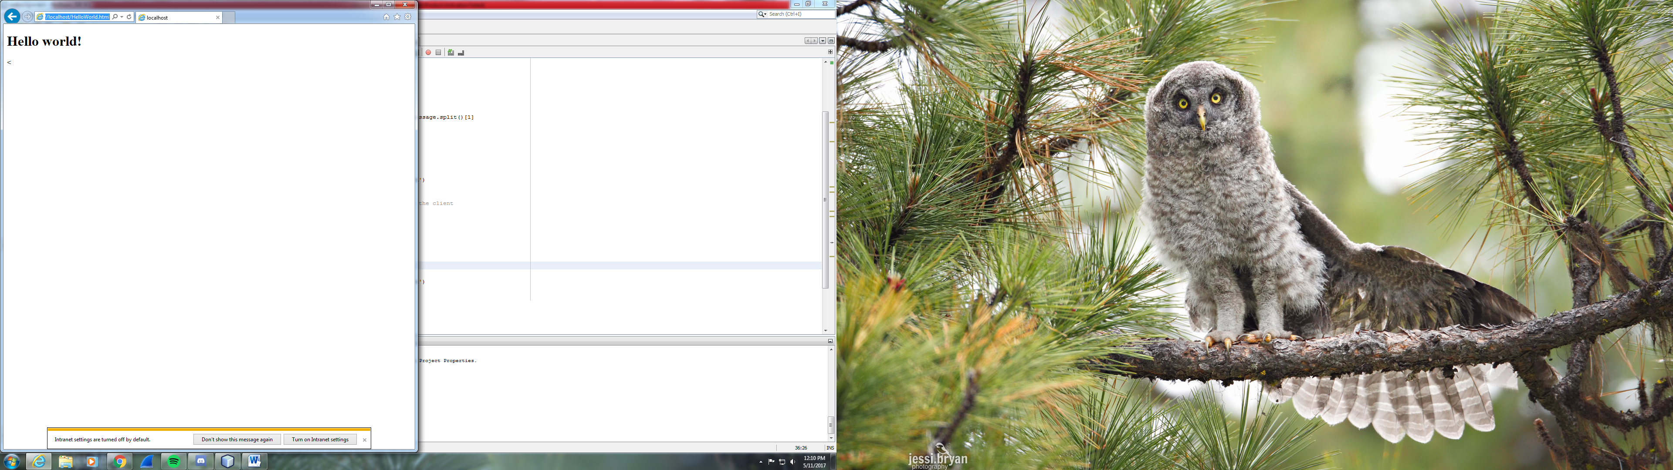

File requested is not available